COLLEGE OF COMPUTER STUDIES AND INFORMATION TECHNOLOGY
IT 307 – Event-Driven Programming
Midterm Exam
1st Semester, S.Y. 2025 – 2026

NAME: ____________________________________________________________ DATE: ______________
YEAR AND SECTION: ____________________________________________ SCORE: ______________

- General Instruction: Remember and understand how event-driven programming works using JavaScript. Answer the questions that ask you to identify what each part of the code does, explain how the browser responds when the button is clicked, and describe how the webpage updates. You are also expected to apply what you know by thinking of ways to improve or change the code, such as adding another event. Some questions will ask you to analyze how the code works together and evaluate its behavior. Finally, you may be asked to create new ideas based on the same logic. Read the code carefully and answer the What, Which, and How questions using keywords and concepts from the code.
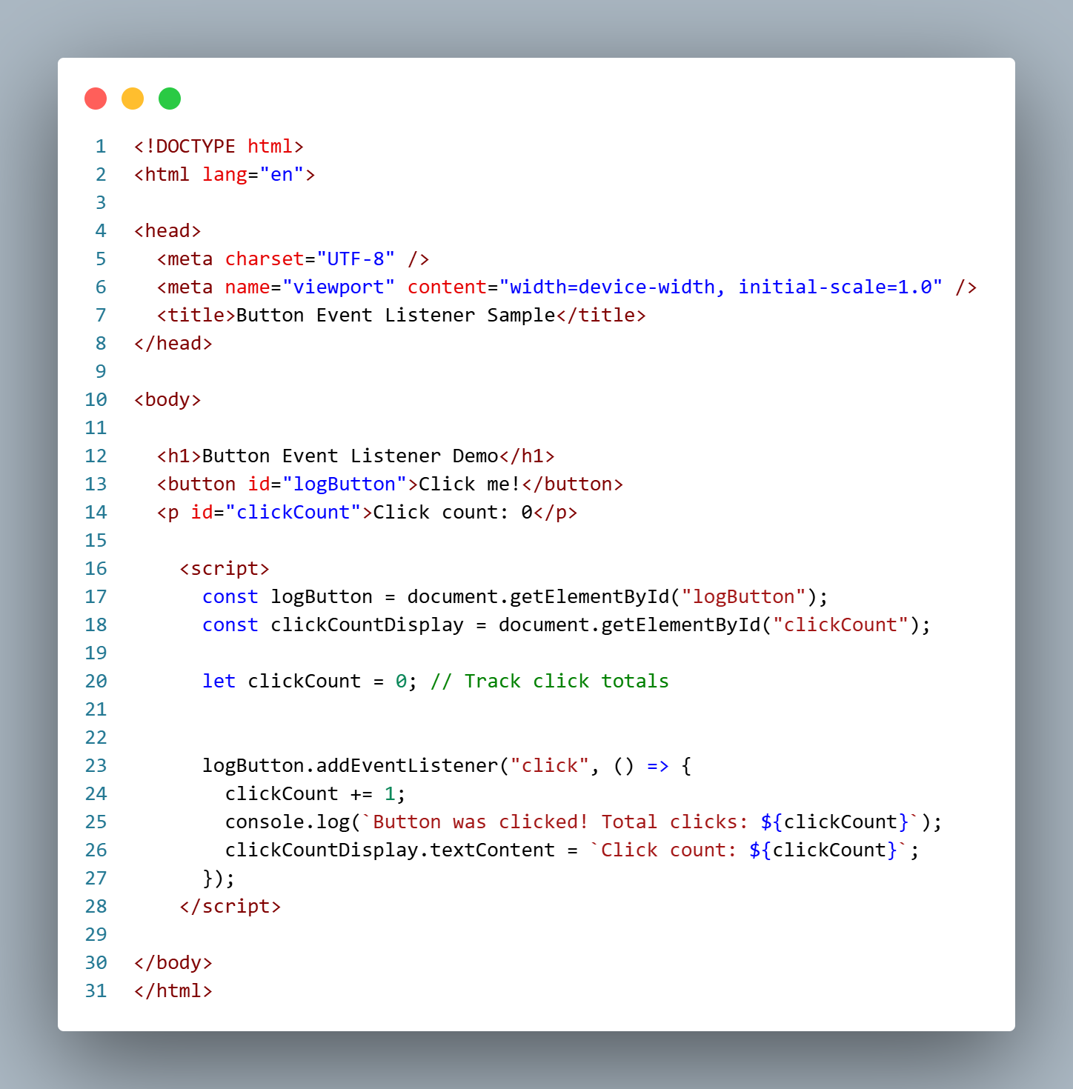

Questions:

- What element triggers the event?
- What type of event is used?
- What does clickCount += 1 do?
- What is updated on the page?
- What does textContent modify?
- What is the initial count value?
- What does console.log() show?
- Which element shows the count?
- Which method adds the event?
- Which variable stores the count?
- Which function runs on click?
- Which part changes the display?
- Which ID is used for the button?
- Which tag contains the script?
- How is the button selected?
- How does the count increase?
- How is the UI updated?
- How is the event handled?
- How is output shown in console?
- How does the code respond?

- Rubrics

Score | Description | Criteria
1.00 (Precise Answer) | The answer is completely correct and matches the concept or term used in the code. | Student gives the exact keyword, function, event, element, or behavior that corresponds to the question. Demonstrates full understanding of the code.
0.75 (Almost Correct) | The answer is mostly correct but has a minor mistake or uses slightly different wording. | Student shows clear understanding but may have small errors in syntax, phrasing, or explanation.
0.50 (Intermediate) | The answer is partly correct or incomplete. | Student identifies a related concept but misses key details or uses vague terms.
0.00 (Wrong/No Answer) | The answer is incorrect, irrelevant, or missing. | Student fails to identify the correct concept, term, or behavior related to the question.

Scoring Guide
Item Range | Total Points Possible | Description
20 items × 1 point each | 20 points total | Each question is graded individually based on accuracy using the 1–0 scale.

Prepared by:

JUNNIE RYH M. SUMACOT
Instructor

Approved:

SHERWIN G. CADAY,
Program Chair, IT Department

Answers Key

- What element triggers the event?
→ logButton
- What type of event is used?
→ click
- What does clickCount += 1 do?
→ Increments the count
- What is updated on the page?
→ clickCountDisplay
- What does textContent modify?
→ Paragraph text
- What is the initial count value?
→ 0
- What does console.log() show?
→ Click message
- Which element shows the count?
→ <p id="clickCount">
- Which method adds the event?
→ addEventListener()
- Which variable stores the count?
→ clickCount
- Which function runs on click?
→ Arrow function
- Which part changes the display?
→ textContent = ...
- Which ID is used for the button?
→ logButton
- Which tag contains the script?
→ <script>
- How is the button selected?
→ getElementById()
- How does the count increase?
→ clickCount += 1
- How is the UI updated?
→ textContent
- How is the event handled?
→ Arrow function
- How is output shown in console?
→ console.log()
- How does the code respond?
→ On button click
OLLEGE OF COMPUTER STUDIES AND INFORMATION TECHNOLOGY
IT 307L – Event-Driven Programming [Laboratory]
Midterm Exam
1st Semester, S.Y. 2025 – 2026

NAME: ____________________________________________________________ DATE: ______________
YEAR AND SECTION: ____________________________________________ SCORE: ______________

    - Comprehensive Instruction:
Objective:
To create a simple webpage that responds to at least 5 different user actions (events) using JavaScript and DOM manipulation.

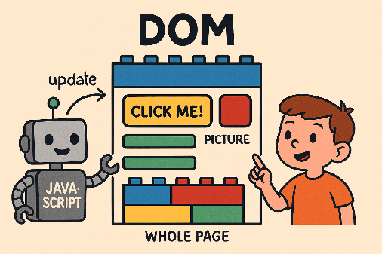
📋 Instructions for Students:
- Project Overview
You will build a webpage that includes:
- A button
- A text input
- A paragraph
- A heading
- A color-changing box
Each element will respond to a different event using JavaScript.

- Required Events (Minimum of 5)

Your project must include the following types of events:

Event Type | Example Interaction
click | Button click to increase a counter
mouseover | Hovering over a box changes its color
keydown | Typing in an input field logs the key
dblclick | Double-clicking a heading changes text
change | Selecting a new value updates a message

You may add more events like submit, focus, blur, or scroll for bonus points.

- Project Requirements
- Use HTML to structure the page.
- Use JavaScript to handle events.
- Use DOM methods like getElementById, addEventListener, and textContent.
- Display feedback on the page (not just in the console).
- Code must be well-indented, commented, and organized.

- Suggested Layout
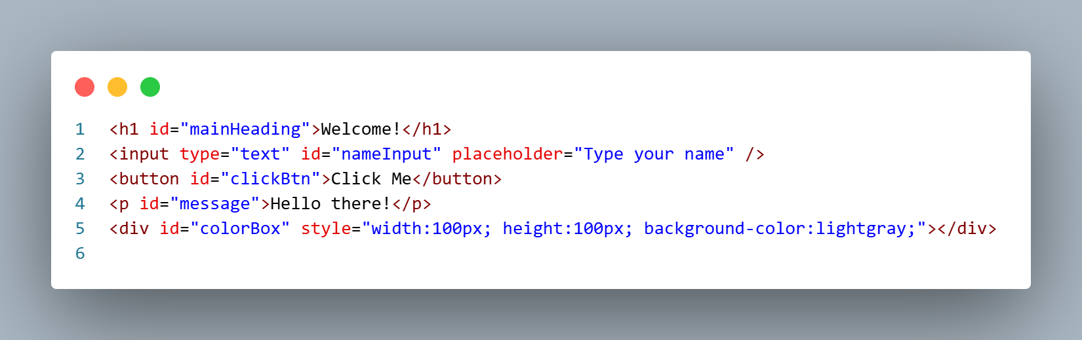

- Sample JavaScript Snippets
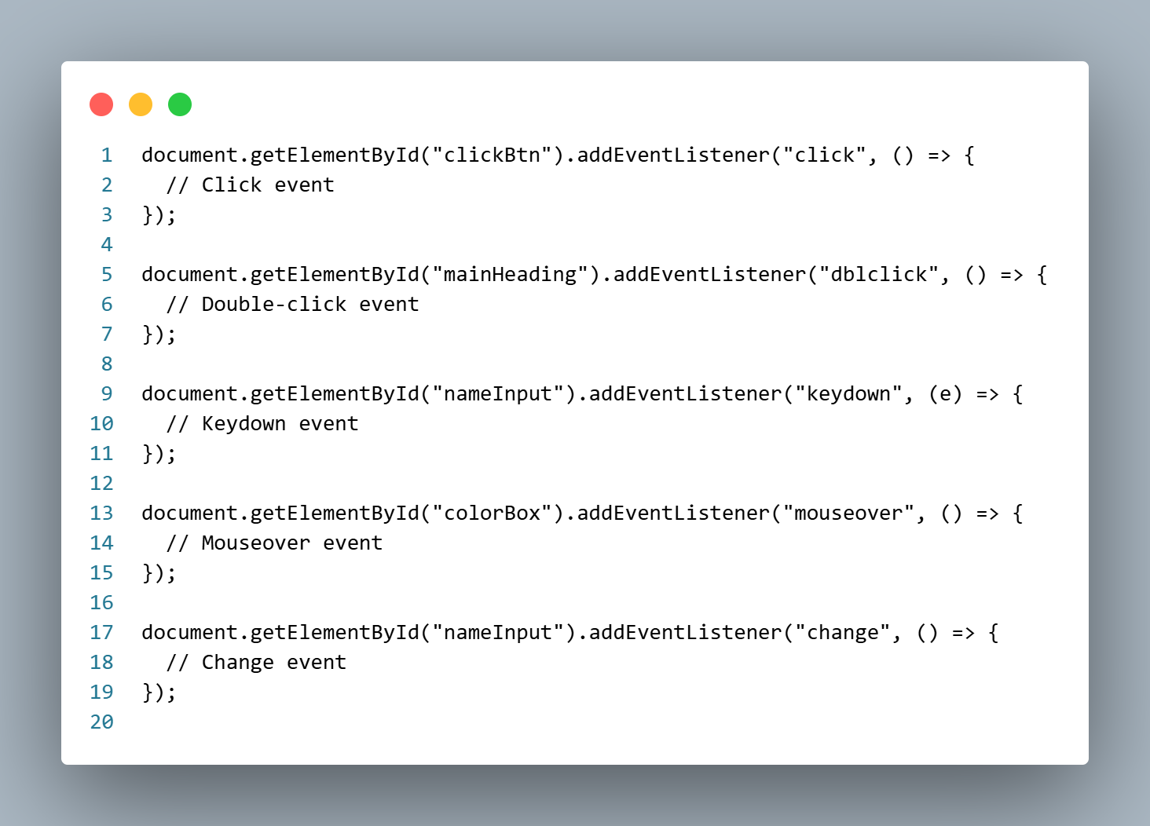

    - Rubrics (20 Points Total)

Criteria | Excellent (20 pts) | Good (15 pts) | Fair (10 pts) | Needs Improvement (5 pts) | Total Points
1. Events Implemented (20 pts) | Implements 5 or more functional and relevant events correctly; each event responds properly and enhances interaction. | Implements 3–4 working events with minor issues or limited interactivity. | Implements 1–2 events that function but lack completeness or relevance. | Events are missing or non-functional; poor or no interaction achieved. | /20
2. DOM Manipulation Used (20 pts) | Uses DOM methods effectively (getElementById, textContent, etc.) to update and control webpage elements dynamically. | Uses DOM manipulation correctly in most parts, with minor logic or syntax errors. | Uses limited DOM manipulation; partially functional or inconsistent results. | Little to no DOM manipulation applied or mostly incorrect implementation. | /20
3. Code Accuracy & Functionality (20 pts) | Code runs without errors, performs expected results, and meets all requirements; shows logical and efficient structure. | Code is mostly correct and functional with minor bugs or syntax issues. | Code partially works; some functions incomplete or incorrect output. | Code does not run properly or shows multiple logic/syntax errors. | /20
4. Code Clarity & Comments (20 pts) | Code is well-organized, readable, and properly commented; variable names and structure follow best practices. | Code is clear with some comments and readable structure. | Code works but is hard to read or has few comments. | Code lacks clarity, structure, or any meaningful comments. | /20
5. Creativity & Presentation (20 pts) | Shows originality and creativity in design, features, and user interaction; visually appealing and well-presented. | Demonstrates creativity with some unique ideas; presentation is neat. | Basic presentation; limited creativity or repetitive design. | Lacks creativity; poor or unappealing presentation. | /20

Scoring Summary:
Criteria | Points Possible
Events Implemented | 20
DOM Manipulation Used | 20
Code Accuracy & Functionality | 20
Code Clarity & Comments | 20
Creativity & Presentation | 20
Total | 100 Points

Submission Guidelines
- Submit your project as a .html file.
- Include your name and section in a comment at the top.
- Deadline: Before time given ends

Prepared by:

JUNNIE RYH M. SUMACOT
Instructor

Approved:

SHERWIN G. CADAY,
Program Chair, IT Department

